

**Asset Practice Questions: Mathematics**

1. The given figure shows the contents page of a Mathematics book.

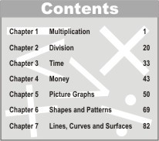

How many pages long is the chapter on *Shapes and Patterns*?

A. 82

B. 69

C. 27

D. 13

2. Manas is playing a computer game. Each time he plays the game, he either gets a star or a sparkie. He gets 5 points for a star and 10 points for a sparkie.

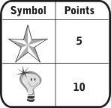

He played 6 games and for each game he got the following:

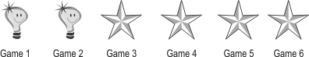

How many points did he score?

A. 6

B. 24

C. 40

D. 60

3. Study how the numbers are written in the boxes given below.



Following the same pattern, the numbers 13, 14, 15, 16 have to be written in the box below.



The number that should come in place of ''X'' is

A. 13. B. 14. C. 15. D. 16.

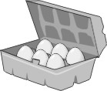4. A shopkeeper sells egg crates with 6 eggs in each.

If I want 30 eggs, how many egg crates should I ask for?

A. 5

B. 6

C. 24

D. 30

5. Look at the pattern on this number train:



Which number between 50 and 60 will be on this number train?

A. 52

B. 54

C. 56

D. 58

6. Rina has some stamps. Jiya gave her 13 more stamps. If Rina has 29 stamps now, how many did she have in the beginning?

A. 16

B. 26

C. 32

D. 42

7. Tia has 14 pencils and Ravi has 20 pencils. How many pencils should Ravi give away to Tia so that both of them have the same number of pencils?

A. 2

B. 3

C. 5

D. 6

8. 4 boys and 6 girls were sitting on a bench. Each one put 3 notebooks on the desk. In all, how many notebooks were on the desk?

A. 10

B. 13

C. 18

D. 30

9. See the number chart below. This is a '1 to 100' chart with three lines completed. The chart goes on the same way up to 100:

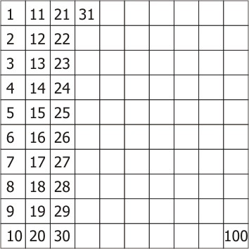

The number that comes in the box to the LEFT OF 54 in the chart is

A. 1 less than 54.

B. 1 more than 54.

C. 10 less than 54.

D. 10 more than 54.

10. Each bag shown below contains 10 balls.

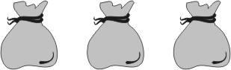

ALL the balls are taken out of the second bag. They are then put into the first bag. Totally how many balls are there in the three bags now?

A. 20

B. 30

C. 40

D. We cannot say without counting them again.

11. Tina is counting the number of paintings in the painting hall of her school. She has reached the 67th

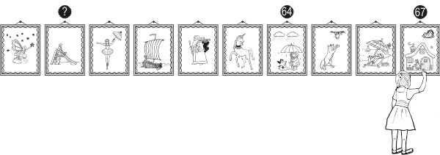painting.

What would be the number of the painting showing the question mark in the figure given?

A. 61

B. 58

C. 59

D. 69

12. Here are some number cards.

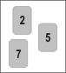

Which is the largest 2-digit number that can be formed using the number cards shown above?

A. 25

B. 57

C. 75

D. 99